First Fundraiser of the Season!
Chicken Barbeque
In partnership with Bunker Hill Fire Company
Saturday, September 22, 2018
WE NEED YOU!!
Sign Up for a 2-hour shift
Bring a baked good (wrapped for single serving)
We need students and parents to help us with this one. (2 parents per 4 kids)
Please see Rhonda Ford at drop off (6pm) or pick up (9pm) any rehearsal night, email me at RhondaF56@comcast.net, or use Computer Sign Up (coming soon)
First come, first serve on shifts!
We will have to staff this event from 5:30am to about 12 noon.
THANKS IN ADVANCE

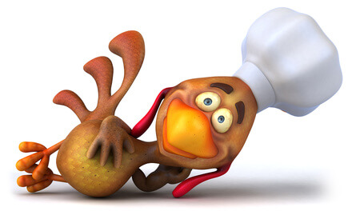

Northern Lebanon Marching Band Fundraising Commitment (Second Request)
Fundraising is a vital part of our existence. The cost of Drum Major training, uniform dry cleaning, equipment maintenance and repairs, props, food, banquet are just a few of our expenses. Volunteers supply our kids with moral support, properly fitted uniforms, fun activities and accompany our children to football games and Cavalcades. Please take the time to complete this form.
This year’s mandatory fundraising options are as follows: Please note we are adding a buyout option for 2 of the 3 fundraisers.
#1 Chicken BBQ (September 22, 2018)
Parent/Adult Representative: Work a 2-hour shift. You can sign up on Time to sign up Student Part (flyer attached)
o Spend 2 hours filling chicken bags/attending the chicken cooking station.
o Help create foot traffic at booth by holding signs, playing instruments, etc. Section leaders will call sections to encourage participation at the event.
NOTE: Help may be needed on Friday, September 21st to wrap potatoes. Let me know if you are available so I can pass info onto fire company for further instructions.
Buyout: ** There is no Buyout option for this event**
#2 Gertrude Hawk Candy Bars (Fall 2018)
Parent/Adult Representative: Pick up box of candy bars. Student Part:
o Sell a minimum of 1 box of 40 candy bars.
o Section leaders will motivate sections with challenges to be the top selling section.
Buyout: $40 (Student does not have to sell Candy Bars)
#3 R&K Subs (Winter 2018)
Parent/Adult Representative: Pick up and distribute the R&K Subs sold by your child. Student Part:
o Sell a minimum of 10 R&K Subs.
o Section leaders will motivate sections with challenges to be the top selling section.
Buyout: $20 (Student does not have to sell R&K Subs)
--------------------------------------------------------------------------------------------------------------------------------------------------------
Please detach and return by FRIDAY, SEPTEMBER 7, 2018 – ALL BUYOUT PAYMENTS ARE DUE NOW
Parent’s Name: __________________________________ For Band Member: __________________________________
_______ I/We will participate in both fundraisers selling the minimum for both Gertrude Hawk and R&K Subs.
_______ I/We will participate in the Gertrude Hawk or Sub fundraiser (circle which one) and 1 buyout. My buyout is included.
_______ Attached is the $60.00 buyout for both fundraisers. I do not have to sell!! (Cash or Checks payable to NL Band Parents)
Thank you for supporting your Child’s commitment to Marching Band!!

